

Republic Services

#53 – Break Out CSAs (Highlighting TCs)

Julie Felberg | February 20, 2015

|  |  |  |  |
| --- | --- | --- | --- |
| Category | Documents | Sub Category | Documents - Doc Engine |
| Use Case |  | Test Case |  |
| LOE |  | Go Live Date |  |

# Business Reason

## This item was derived from a task of creating the ability to high-light the second page of the CSA (initials section) similar to the signature lines on the first page. John briefly looked into and mentioned we may need to break out the CSA's into individual documents. Perhaps there is a better way?.

# Task Requirements

1. Determine if we can add highlighting to the second page of the Terms and Conditions while keeping the current CSA- TCs structure.
   1. Proof of Concept
2. Meet with Yi (Customer Support) to discuss why we would break out the Terms and Conditions.
3. Implement
   1. Highlight the customer signature and date on the second page of Terms and Conditions for all 20+Terms and Conditions

# Build Plan

Proof of Concept

1. Doc Engine 🡪 CSA (CSA_bmDocEdClone_7) document 🡪 CSARearTC page
2. RearTAndC complex conditional
3. Work with rearTC_14
   1. Remove the old customer signature and date lines
   2. Replace with a table with the following properties

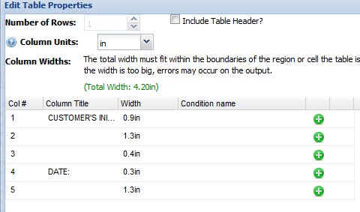

* 1. Fill in the 1st column with “Customer Signature:” and the 4th column with “Date:”
  2. Apply background color to the 2nd and 5th columns.

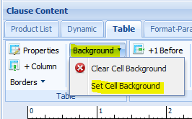

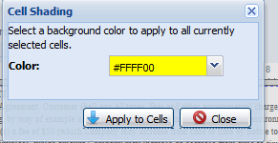

* 1. Apply bottom borders to the 2nd and 5th columns.

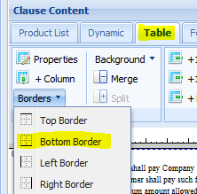

* 1. In the end, the table should look like this:

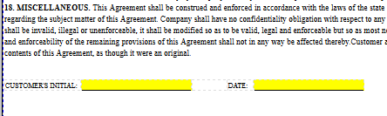

# Implementation Profile Changes

## Not yet.

# User Guide Changes

## Note yet.